# Using Deep Learning and Evolutionary Algorithms for Time Series Forecasting (2018)

## Motivation and background

Analysis of time-series data has been the subject of active research going back decades and is considered one of the top 10 challenges in data mining. As noted by the authors several different ANN models have been applied to this problem with some success. Furthermore, finding optimal set of hyperparameters is noted a one of the major challenges related to the complexity of applying machine learning methods to this problem space.

## Research objective/question(s)

Thesis aims to assess performance of deep learning algorithms optimized by evolutionary algorithms; specifically Evolutionary algorithm: CMAES (Covariance Matrix Adaptation Evolution Strategy) applied to the hyperparameter optimization problem

* Comparison of:
  + Feedforward multilayer perceptron (MLP) – Fully Connected (each nueron connected to next layer (three layer below)
    - 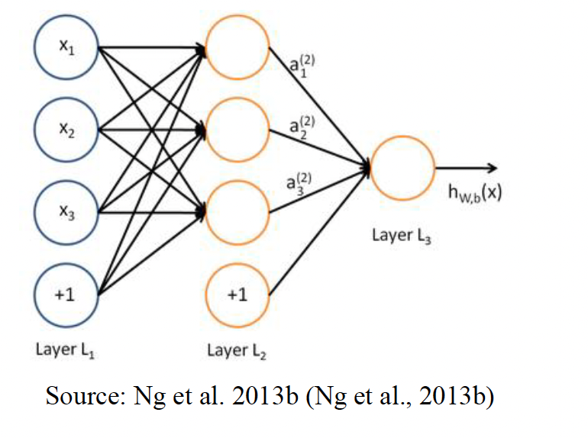
  + Stacked Autoencoder (SAE) – multiple layer of Autoencoders
    - Popular as they provide feature extraction
    - Think feature 1, feature 2, followed by softmax classifier
    - 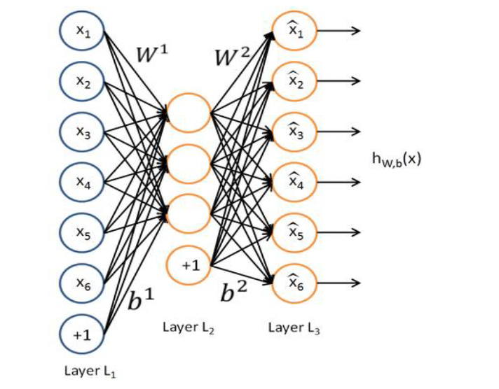
  + Stack Denoising Autoencoder (SDAE) – Similar to SAE but input corruption only on initial training of each layer
    - Corruption techniques
      * Additive Gaussian Noise (add random value)
      * Masking Noise (to handle missing values)
  + Long Short-Term Memory Networks (LSTM)

## Prior relevant work/literature gap

* Deep Learning and Evolutionary Algorithms applied to time series
  + Time-series approaches looked at
    - Lv et al., 2015 – traffic flow (traffic data) using stacked autoencoder (SAE) to learn temporal features
    - Kuremoto et al, 2014 – Deep Belief Networks – multiple layers of restricted Boltzmann machines (RBMs) to predict competition time series against MLP, Bayesian and Arima
    - Grover et all, 2015 – DBNs applied to weather
    - Thierou et al., 2007 – LSTM bi-directional model
  + Evolutionary approached looked at
    - Nalepa and Kawulok, 2014 – Evolutionary algorithms applied to hyperparameter optimization very effective
    - Gonzalez et al., 2015 – GA applied to both hyperparameters and feature selection – improved stability of Support vector machines and outperforming Tsai et al, 2006 previous work
    - Kennedy and Eberhart, 1995 - Particle Swarm Optimization applied to two hyperparameter optimization problems
      * Kuremoto et al., 2014 – applied to DBN
        + Number of neurons in hidden layer
        + Learning rates
        + Time lag (e.g. period)
      * Lorenzo et al, 2017 – applied to solution space – looking at a minimum topology and optimize hyperparameters by PSO to achieve competitive image classification
    - Loshchilov et al., 2016 – Propose CMAES optimize parameters of a CNN
* Author integrated techniques of time forecasting and applied evolutionary algorithms

## Theory, conceptual framing

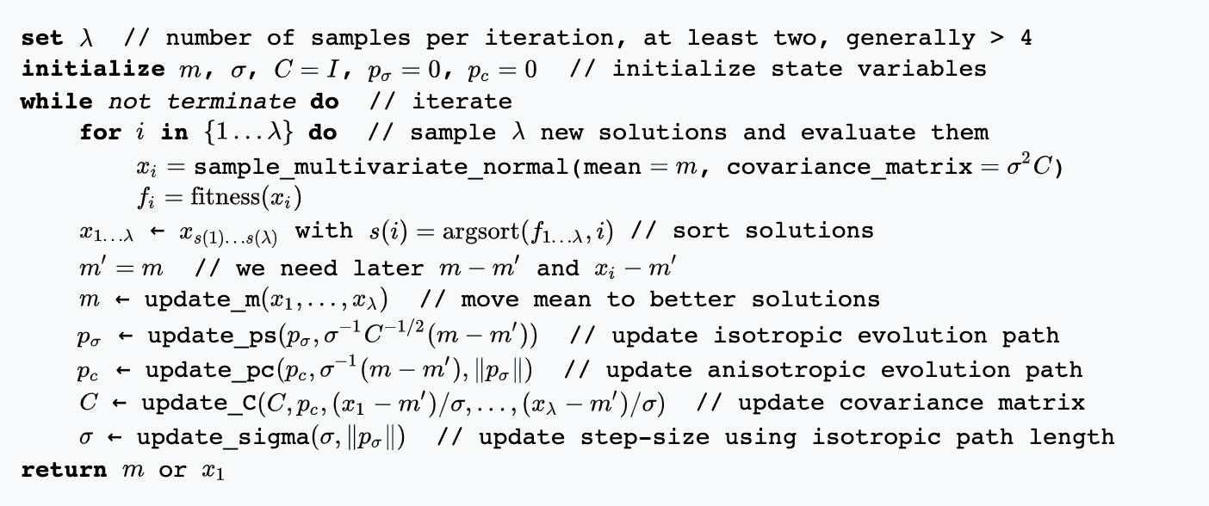

Each iteration step a weighted combination of the *μ* best out of *λ* new candidate solutions is used to update the distribution parameters.

Main loop consists of three parts

1. Sampling new solutions
2. Re-ordering of the sampled solutions based on their fitness
3. Update of the internal state variables based on the re-ordered sample

Basically, leverages a maximum likelihood principle as exploited through a covariance matrix that describes correlations between decision variables. Relying on normal distributed mutative steps to explore search space to make steps in the most-likely future.

The author notes that this method is a good option for non-linear optimization problems by overcoming the following in other evolutionary algorithms:

* Poor performance – on badly scale and or highly non-separatable objective functions (update covariance above)
* Inherent need to use large population sizes
* Premature convergence (step wise update above)

## Methods

Experiment setup:

In this work CMAES algorithm is used to perform the slection of hyperparameters for each model in each dataset.

* Population size (*λ*) set to 24
* Maximum number of generations (𝑔𝑚𝑎𝑥=150)

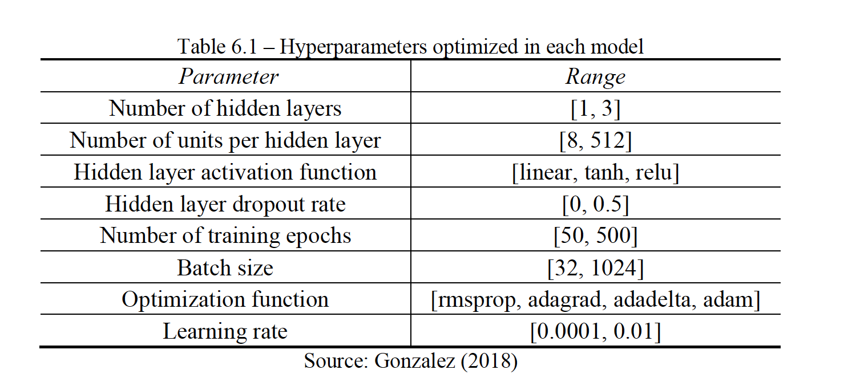

Error and performance metrics used

* Mean Absolute Error (MAE) 𝑀𝐴𝐸=(1/𝑁)Σ|𝑍𝑡−𝑍𝑡̂|
* Mean Squared Error (MSE) 𝑀𝑆𝐸=(1/𝑁)Σ(𝑍𝑡−𝑍𝑡̂)2
* Root Mean Squared Error (RMSE) 𝑅𝑀𝑆𝐸=√((1/𝑁)Σ(𝑍𝑡−𝑍𝑡̂)2)

Benchmark datasets:

* Random – Mackey-Glass and Lorenz System
  + The Mackey–Glass (MG) model (Mackey and Glass, 1977) describes the dynamics of physiological time delayed processes, mainly respiratory and hematopoietic (i.e. formation of blood cellular components)

* + Lorenz (Lorenz, 1963) proposed the Lorenz Attractor System in his attempt to model how an air current rises and falls while being heated by the sun. (Known for butterfly effect)

* Real data – Energy demand

The Augmented Dickey-Fuller (ADF) (Greene, 2003) test is a type of statistical test called a unit root test. The intuition behind a unit root test is that it determines how strongly a time series is defined by a trend. Think seasonality of the dataset (as does show up in economic cycles).

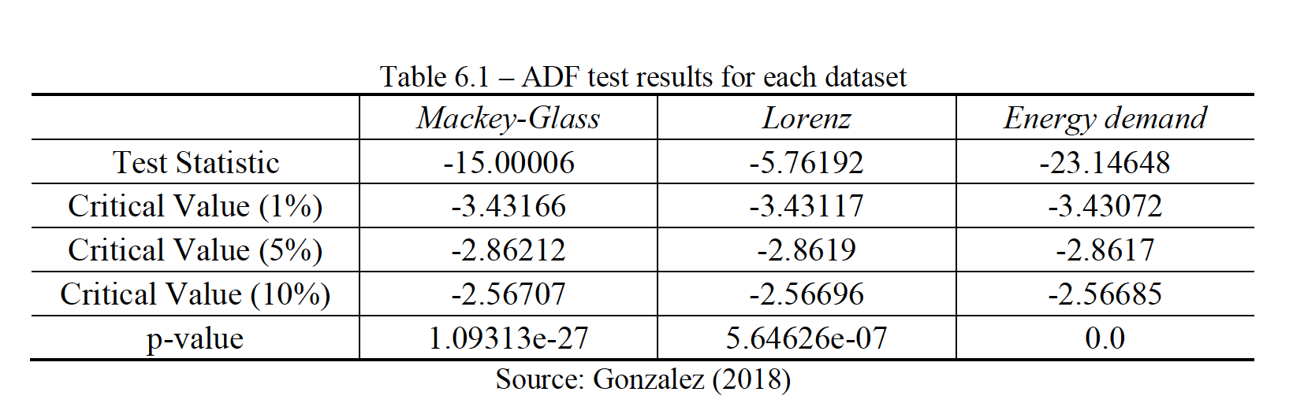

With a p-value under 0.05 therefore reject null hypothesis meaning these datasets are stationary

## Results

Mackey-Glass

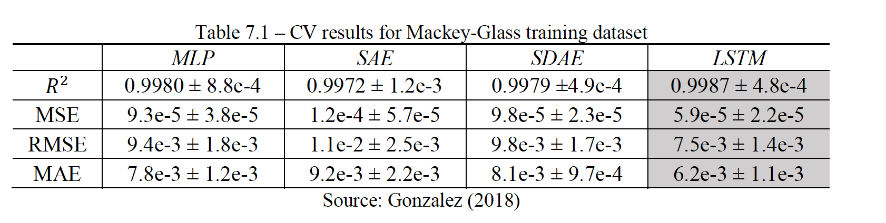

* Best result is highlighted
* MLP was the base model
* LSTM provided best performance

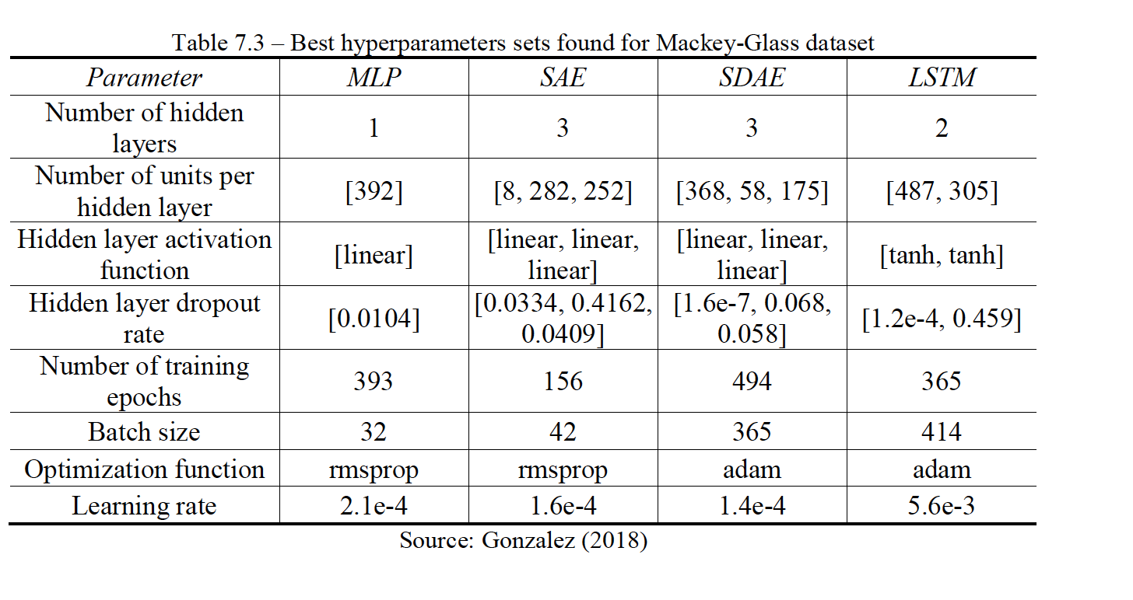

Lorenz System

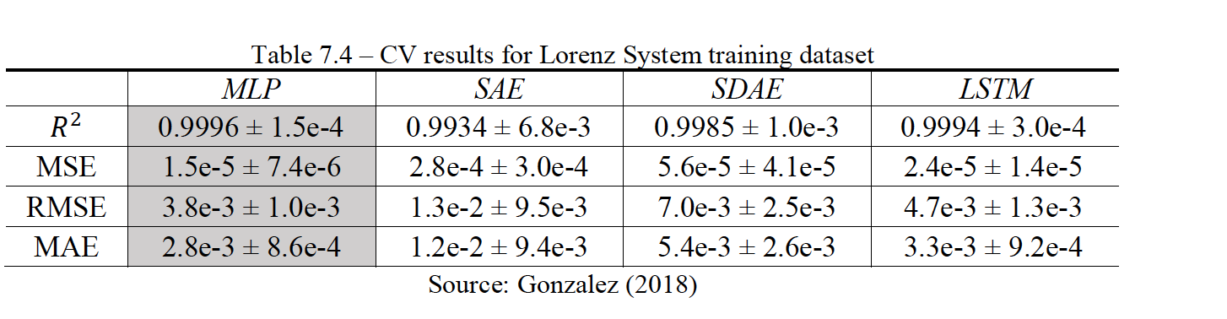

* Standard MLP outperformed
* LSTM performed the worst

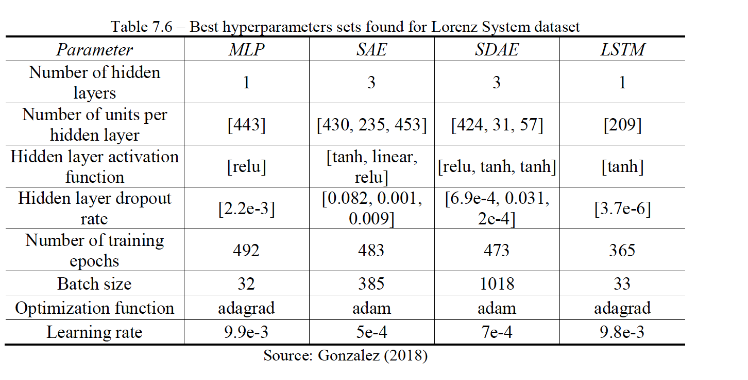

Energy Demand

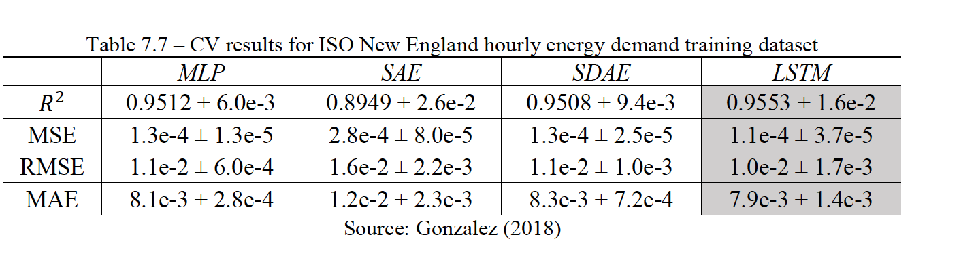

* LSTM outperforms

## Discussion

The proposed approach by the author leveraging CMAES applied to hyperparameter optimization did improve forecasting accuracy. Method works well in the case of short-term forecasting with an acceptable error as noted. Overall, an effective tool as applied to hyperparameter optimization.

* LSTM, MLP work better on seasonal data
* SAE and SDAE had difficulties learning time-structure

## Thoughts

The author does note that ignoring time and processing temporal significance which I believe TCN (temporal convolutional networks address) where time-dependent series are captured.

Applying CMAES to TCN (with a large number of hyperparameters) and also additional architectural elements (like the dilation factors) or to the Encoder-Decoder applied to the convolutional layers

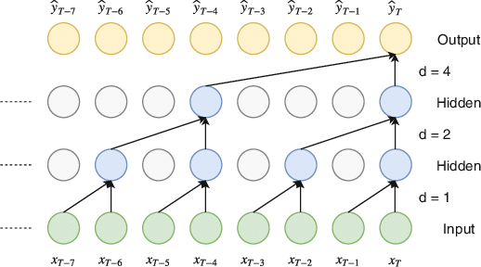

Figure 1

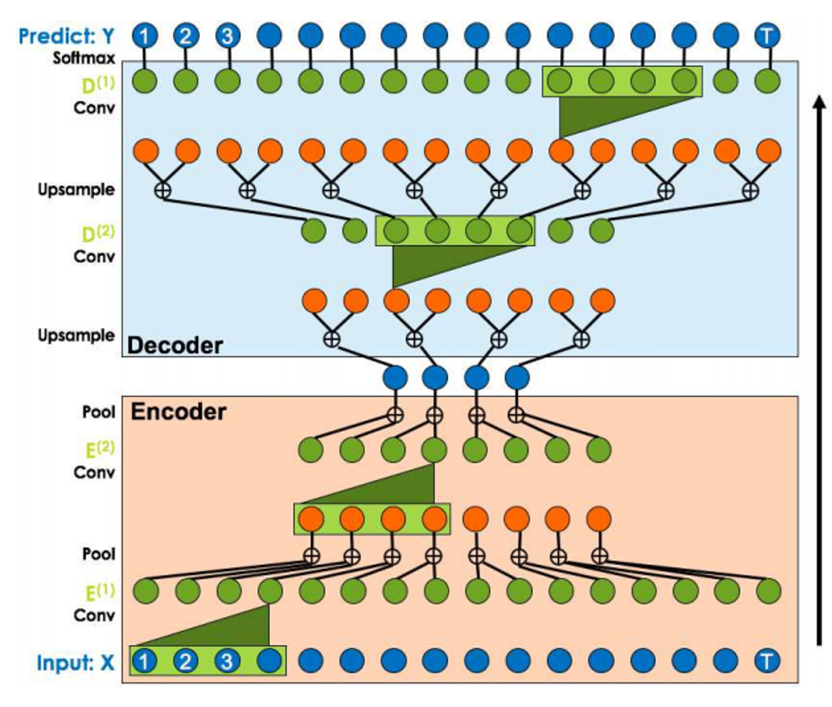

Figure 2

